**Eaton Guide Specification**

**Notes and instructions to specwriter**

The following guide specification is offered for your assistance in specifying this product as part of a CSI (Construction Specification Institute) compliant document.

This guide specification has been created in MS Word and uses Word features including **Styles** and **Review** to assist in editing and formatting. You may also find it helpful to view the document in **Outline** mode when editing or selecting sections to copy/paste into your base document.

**Styles**

Styles are provided for all paragraph types described in the CSI Masterformat. Applying a Style to text will provide the correct indentation, paragraph letter/number, font, capitalization, etc…. Styles are shown on the right-hand side of the Word “Home” ribbon.

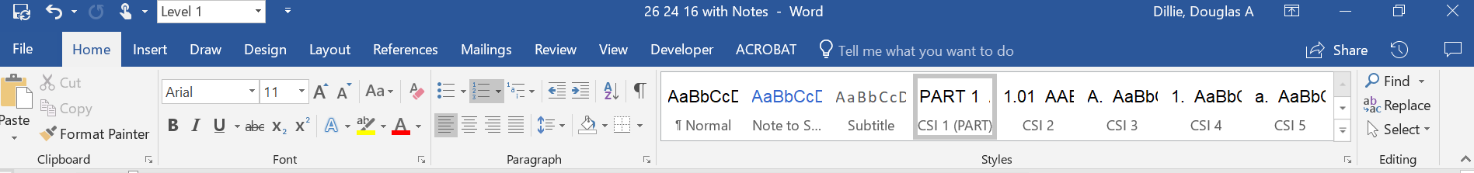

**Review**

“Notes to Specwriter” (when available) are provided using the Reviews feature in Word. To view “Notes to Specwriter” select “All Markup” in the Tracking dropdown menu on the Review ribbon. To hide notes, select “No Markup”. You can advance from one note to the next using the Previous and Next buttons on the same ribbon. In earlier versions of MSWord hide notes by un-checking ‘Comments’ under Review>Show notes. All comments should be deleted before printing or copying.

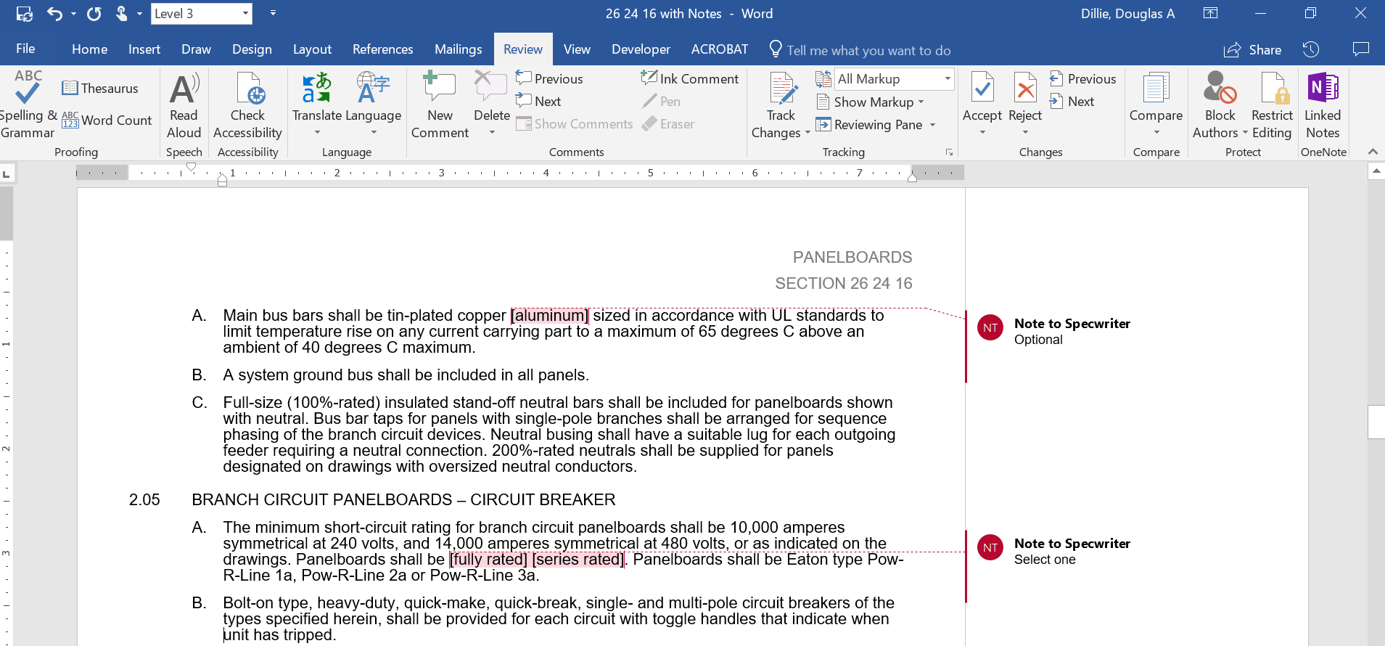

**Outline view**

The Outline view within Word is often helpful when editing or copying sections from this Guide Specification. Also, when pasting sections from this document into a base document the specwriter may want to consider using right-click and “Merge Formatting’ or ‘Keep Text Only” features.

Section 11 11 36.16

level 2 electric vehicle supply equipment

# general

## SUMMARY

### This specification describes the Eaton Green Motion EV Smart Breaker Charger, which is an AC level 2 electric vehicle supply equipment (EVSE) device. The charging station will be integrated within a circuit breaker and shall operate as a smart charger to provide recharge current to battery electric vehicles (BEV) and plug-in hybrid electric vehicles (PHEV) that accept a J1772 plug, or J3400 with adapter(not included).

## References

### The Green Motion EV Smart Breaker Charger shall be designed, manufactured, and tested in accordance with the latest applicable standards of UL and SAE:

#### UL 489 – Standard for Molded Case Circuit Breakers

#### UL 1998 – Standard for Software in Programmable Components

#### UL 2231-1 – Standard for Personnel Protection Systems for Electric Vehicle (EV) Supply Circuits; Part 1: General Requirements

#### UL 2231-2 – Standard for Personnel Protection Systems for Electric Vehicle (EV) Supply Circuits: Particular Requirements for Protection Devices for Use in Charging Systems

#### UL 2251 – Standard for Plugs, Receptacles, and Couplers for Electric Vehicles

#### UL 2594 – Standard for Electric Vehicle Supply Equipment (EVSE)

#### SAE J1772 – Society of Automobile Engineers Electric Vehicle and Plug in Hybrid Electric Vehicle Conductive Charge Coupler, 2017 ed.

#### FCC Part 15 – Radio Frequency Devices

#### OCPP 1.6J – Open Charge Point Protocol, ver. 1.6J

#### NFPA 70 (NEC) Article 625 – Electric Vehicle Power Transfer System

#### Energy Star Certified

## Submittals – for Review/approval

### The following information shall be submitted to the Engineer:

#### Dimension outline drawing

#### Component list

#### Knockout configurations

#### Product data sheets

## submittals – for construction

### The following information shall be submitted for record purposes:

#### Final as-built drawings and information for items listed in Paragraph 1.04, and shall incorporate all changes made during the manufacturing process

#### Wiring diagrams

#### Installation information

## Qualifications

### The manufacturer of the assembly shall be the manufacturer of the major components within the assembly.

### For the equipment specified herein, the manufacturer shall be ISO 9001 or 9002 certified.

### The manufacturer of this equipment shall have produced similar electrical equipment for a minimum period of five (5) years. When requested by the Engineer, an acceptable list of installations with similar equipment shall be provided demonstrating compliance with this requirement.

## WARRANTY

### Seller warrants that the Products manufactured by it will conform to Seller’s applicable specifications and be free from failure due to defects in workmanship and material for three (3) years from the date of original purchase.

## Regulatory Requirements

### The Green Motion EV Smart Breaker Charger shall be UL labeled.

## Delivery, Storage and Handling

### Equipment shall be handled and stored in accordance with the manufacturer’s instructions.

## operation and maintenance manuals

### Equipment operation and maintenance manuals shall be provided with each kit shipped and shall include instruction leaflets and instruction bulletins for the complete assembly and each major component.

# products

## manufacturers

### Eaton

### __________

### __________

The listing of specific manufacturers above does not imply acceptance of their products that do not meet the specified ratings, features and functions. Manufacturers listed above are not relieved from meeting these specifications in their entirety. Products in compliance with the specification and manufactured by others not named will be considered only if pre-approved by the Engineer ten (10) days prior to bid date.

## ratings

### The EVSE shall incorporate an integrated 2-pole circuit breaker, rated for 40A

### The EVSE shall be rated for single-phase, 208VAC or 240VAC, and shall have short-circuit ratings as shown on the drawings or as herein scheduled, but not less than 10,000 amperes rms symmetrical.

### Storage temperature: -40˚C to +60˚C

### Ambient operating temperature: -30˚C to +40˚C

### Maximum charger current: 32A

### Maximum charger power: 7.7kW @ 240VAC

### Output voltage: 208VAC or 240VAC

### Maximum input current: 32A

### Minimum input overcurrent protection (if required): 40A 2-pole circuit breaker

### Input voltage: 208VAC or 240VAC

### Ground fault protection: 20mA

### Charger cord and connector: 25ft cord with SAE J1772 compliant connector

### Connectivity:

#### Wi-fi connected, 2.4GHz (IEEE 802.11 b/g/n)

### Metering: Voltage, current, frequency, and energy (kWh)

#### Accuracy: +/- 0.2% (revenue grade tested to ANSI C12.20)

## construction

### EV Smart Breaker Charger shall be of a single piece construction to include:

#### Integrated 40A thermal magnetic trip element, manually operated

#### Independent fully-rated relay for remote ON/OFF

#### Integral revenue grade metering

#### Integral EV smart charging circuitry

### The EV Smart Breaker Charger will have a Smart Breaker pole and EV charger pole. When mounted in a UL67 panelboard, each device will take four (4) continuous pole spaces.

#### The Smart Breaker pole will include:

##### Smart Breaker status LED – indicates loading on the breaker

###### GREEN – Idle/ready

###### BLUE – Vehicle plugged in ready / charging

###### RED - Fault

##### BlinkUp receiver and network status indicator

#### The EV charger pole will include:

##### EV charger status LED – indicates charging status and fault conditions

##### EV charger heartbeat LED

##### GFCI test button – to initiate ground fault self test

### EV Smart Breaker Chargers shall be molded case type, plug-on (type BR) or bolt-on (type BAB). Multi-pole circuit breakers shall be of a stack pole design to provide electrical phase isolation and have an internal common trip. External handle ties are not acceptable.

### Each pole of the circuit breaker will have inverse time delay overload and instantaneous short-circuit protection by means of both thermal and magnetic sensors.

### The circuit breaker calibration shall not be affected by environmental changes in relative humidity. Breakers shall be calibrated after assembly.

### All EV Smart Breaker Chargers shall have a manually operated thermal magnetic trip operated by a toggle-type handle. The circuit breaker section shall incorporate trip mechanisms that are mechanically trip-free from the handle. The handle position shall provide good visual trip indication.

### EV Smart Breaker Charger will have remote control capability via an internal relay.

### EV Smart Breaker Charger shall be provided with a J1772 compliant connector. The connector shall have built in status indicator lights to provide local indication of charger status. Status is communicated through the breaker via a DC signal in the cordset to the connector. Contractor to install cordset and connector provided from the manufacturer of the breaker. Charger connector handle status indicators shall mimic the breaker status indicators:

###### GREEN – Idle/ready

###### BLUE – Vehicle plugged in ready / charging

###### RED - Fault

## enclosures

### EV Smart Breaker Charger shall be capable of multiple installation options:

#### Direct installation into an Eaton BR (plug on) loadcenter or PRL3X (bolt on) panelboard

##### 25ft of cordset and J1772 connected will be provided separately by the breaker manufacturer and installed by the contractor.

##### For applications for more than 25ft contractor to install junction box provided by breaker manufacturer. Cabling from EV Smart Breaker Charger to junction box not to exceed 250ft. Cabling from breaker to junction box provided and installed by contractor.

#### EV Smart Breaker Charger will be available in a wall charger kit for wall / pedestal mount

##### Wall charger kit shall be outdoor rated, NEMA-3R

##### The wall charger will have a status indicator built into the cover

###### GREEN – Idle/ready

###### BLUE – Vehicle plugged in ready / charging

###### RED - Fault

##### Wall charger will have holster for connector and cord can be wrapped around wall charger enclosure when not in use.

##### Wall charger kit shall be capable of being installed on the Eaton single or dual pedestal

###### Pedestals shall provide internal wire way for power cable routing.

###### Pedestals shall provide hook for storing charge cord when not in use.

###### Dual mount pedestal shall have the chargers back-to-back.

###### Pedestals shall work with all Eaton wall mount level 2 AC chargers.

## SOFTWARE / COMMUNICATIONS

### EV Smart Breaker Charger shall be a Wi-fi connected device. It shall connect to the 2.4GHz (IEEE 802.11 b/g/n) channel of a router.

### With a loss of Wi-fi or internet connectivity, the EV charger shall be able to charge an electric vehicle at a predetermined set rate, or at full rated current, depending on user definition.

### The EV charger shall support “over-the-air” updates (OTA).

### The charger shall utilize the BlinkUpTM technology for commissioning the charger to the cloud-based management system.

### For commercial applications, the EV charger shall support either API integration or OCPP 1.6J (Open Charge Point Protocol version 1.6J) for monitoring and control into 3rd party Charge Point Operator (CPO) software.

### [The Eaton Charging Network Manager (CNM) is a cloud based platform for monitoring, controlling, and monetizing charging stations.]

### [The Eaton CNM does not require the EV driver to download an app. Accessing the charger shall be via a QR code on the charging station that will open a secure web portal on the mobile device.]

### [Payment processing, when required, shall be supported by StripeTM to provide secure payment transactions for charging sessions. Stripe will provide a token to the Eaton CNM to confirm the charging session can being. The Eaton CNM will not store any personal payment information.]

### [The software platform shall provide the site host (owner) the ability to set pricing policies. Pricing policies shall be fully customizable to support the owner’s specific needs.

#### Pricing policies shall support free charging, tiered pricing, and time of use pricing.

#### Pricing policies shall support time-based (per hour charging or per hour plugged in) or energy-based (per kilowatt-hour energy delivered).

#### Pricing policies shall be able to support different pricing structures in time increments designated by the site host (owner).

#### Pricing policies shall also provide a discount structure to allow the site host greater control and flexibility based on their customer profiles.]

### [The software platform shall offer, as an option, EV charging station power management capabilities. The power management function shall allow balancing of EV charging station energy so that total output stays within an infrastructure’s capacity. The power management function shall support:

#### Load balancing

#### Automatic reallocation of power between vehicles

#### Smart power reservation for loss of connectivity protection

#### 3-phase power configurations

#### Multiple power management groups

#### Smart integrations with building management systems and utilities]

### For private residential applications, the EV charger shall support operation via the Eaton EV Charger Manager app installed on an iOS or Android smart phone.

### The EV charger shall support smart charging capabilities such as:

#### Charge session scheduling

#### Adjustable charging rate

#### Remote start/stop of charging session

# execution

## installation

### The equipment shall be installed in accordance with manufacturer’s recommendations. Refer to manufacturer’s installation instructions for additional details.

### The equipment shall conform to all NEC and local codes.

### For pedestal applications, refer to the manufacture’s installation manual for specific site requirements.

## COMMISSIONING

### The EV Smart Breaker Charger will operate in “free mode” if not connected to a network.

### The EV Smart Breaker Charger can be connected to the Eaton Charger Network Manager (CNM) or to a 3rd party network that supports OCPP 1.6J.

#### Commissioning the charger to the Eaton CNM or 3rd party network will be via the Eaton EM Install App.

##### The app will be a free download available on Android and iOS.

##### The app will utilize the BlinkUpTM process for commissioning the device.

##### The app will guide the installer/contractor step by step through the commissioning process.

### The site host provided 2.4GHz router will be used for connecting the EV Smart Breaker Charger.